### Part c - Vertex AI:

### Training and serving a custom model

In this document, there will be screenshots of -

* Build and containerize model training code in Vertex Workbench
* Submit a custom model training job to Vertex AI
* Deploy the trained model to an endpoint, and use that endpoint to get predictions

1. Enabling the required APIs

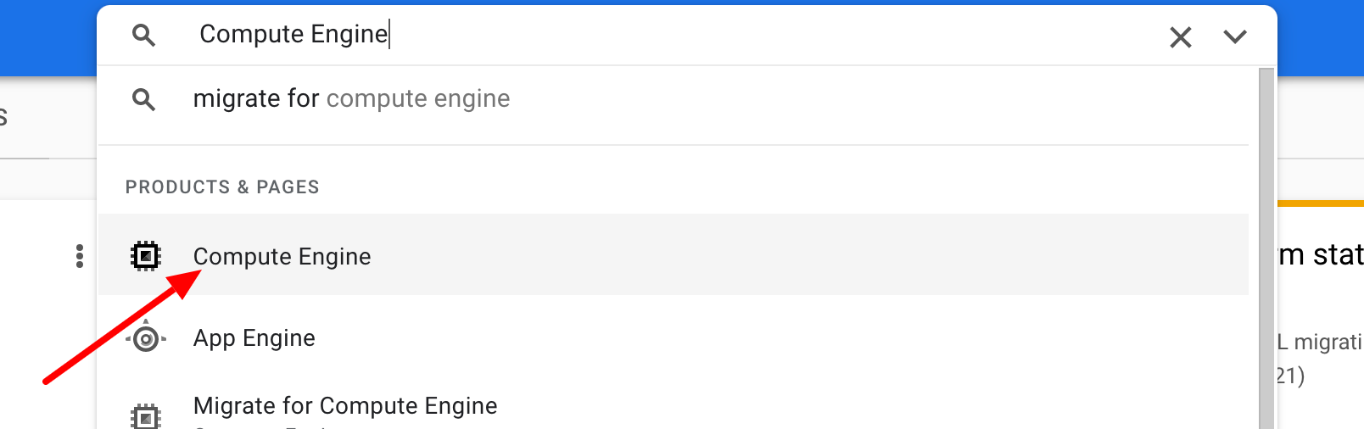

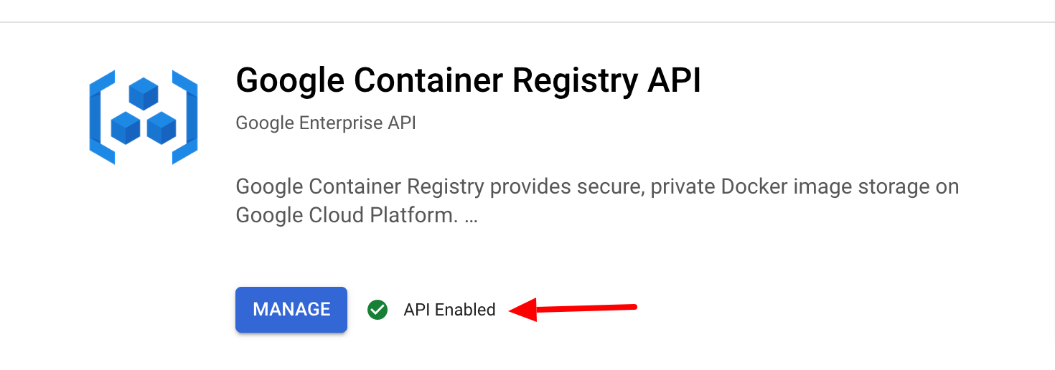

1. Creating a vertex AI notebook instance

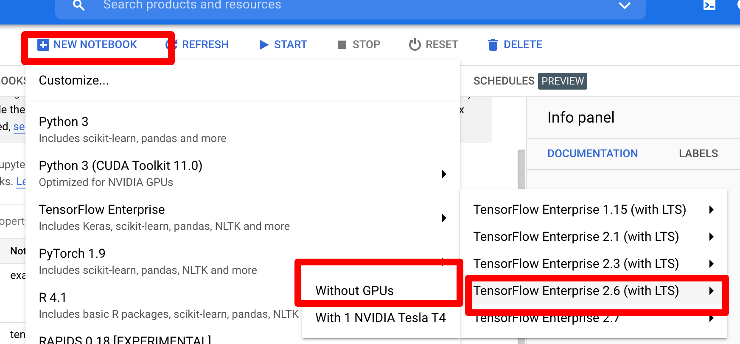

1. Containerizing training code

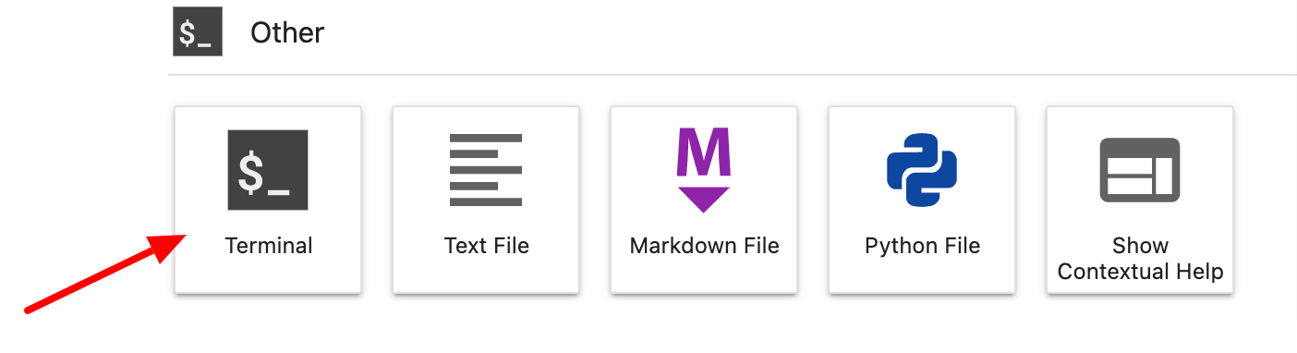

1. Containerizing the code and pushing an image to the google container registry

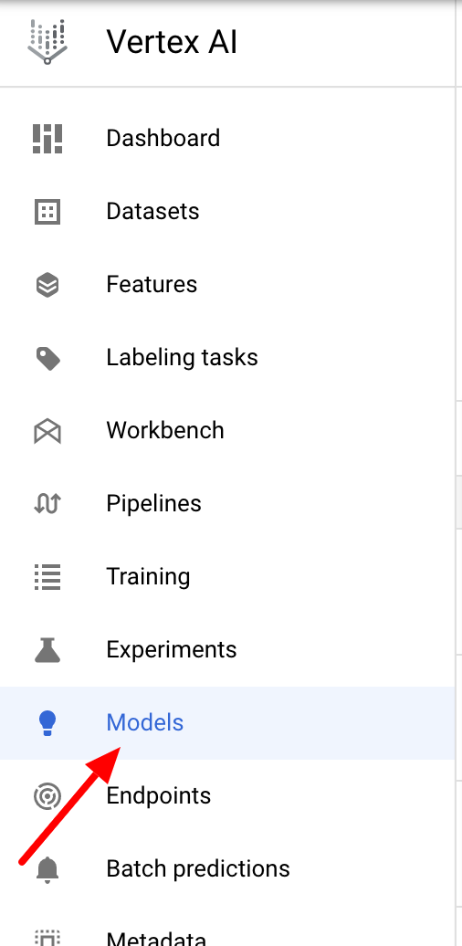

1. Configuring the training by using the custom training container that was pushed to the google container registry

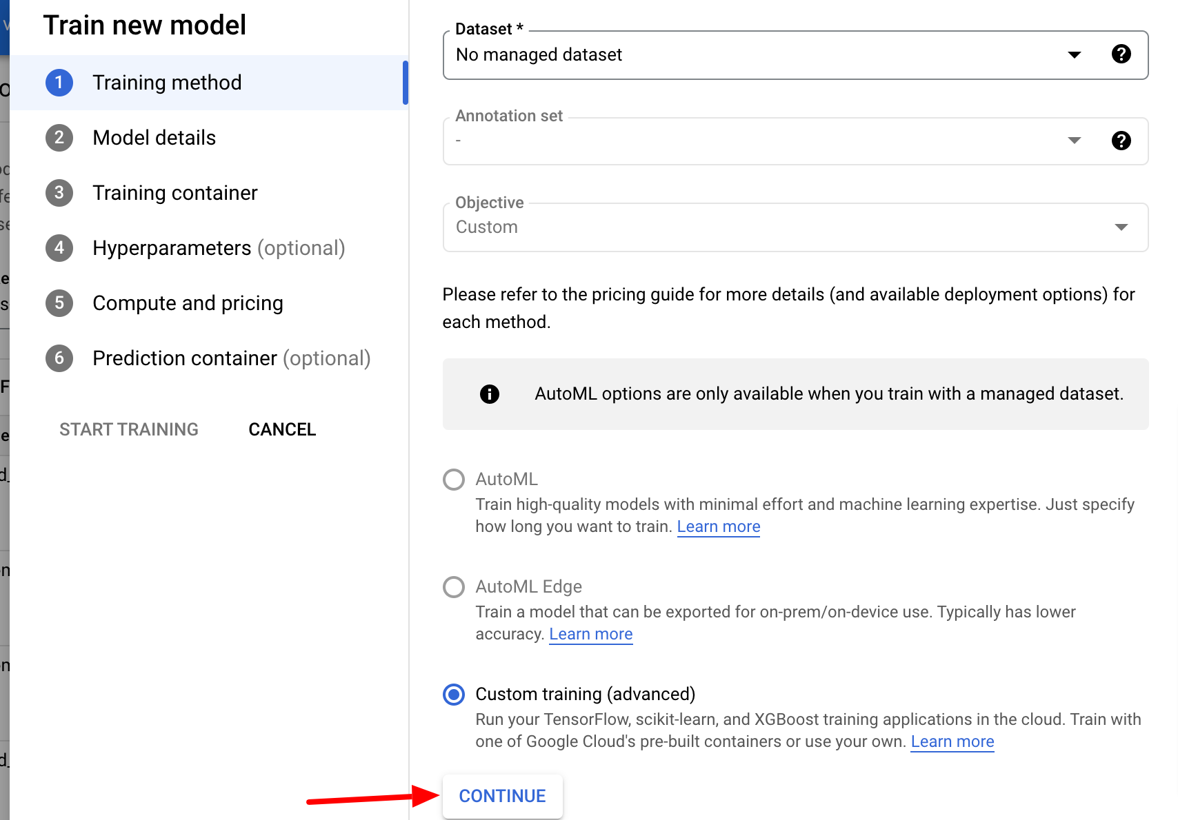

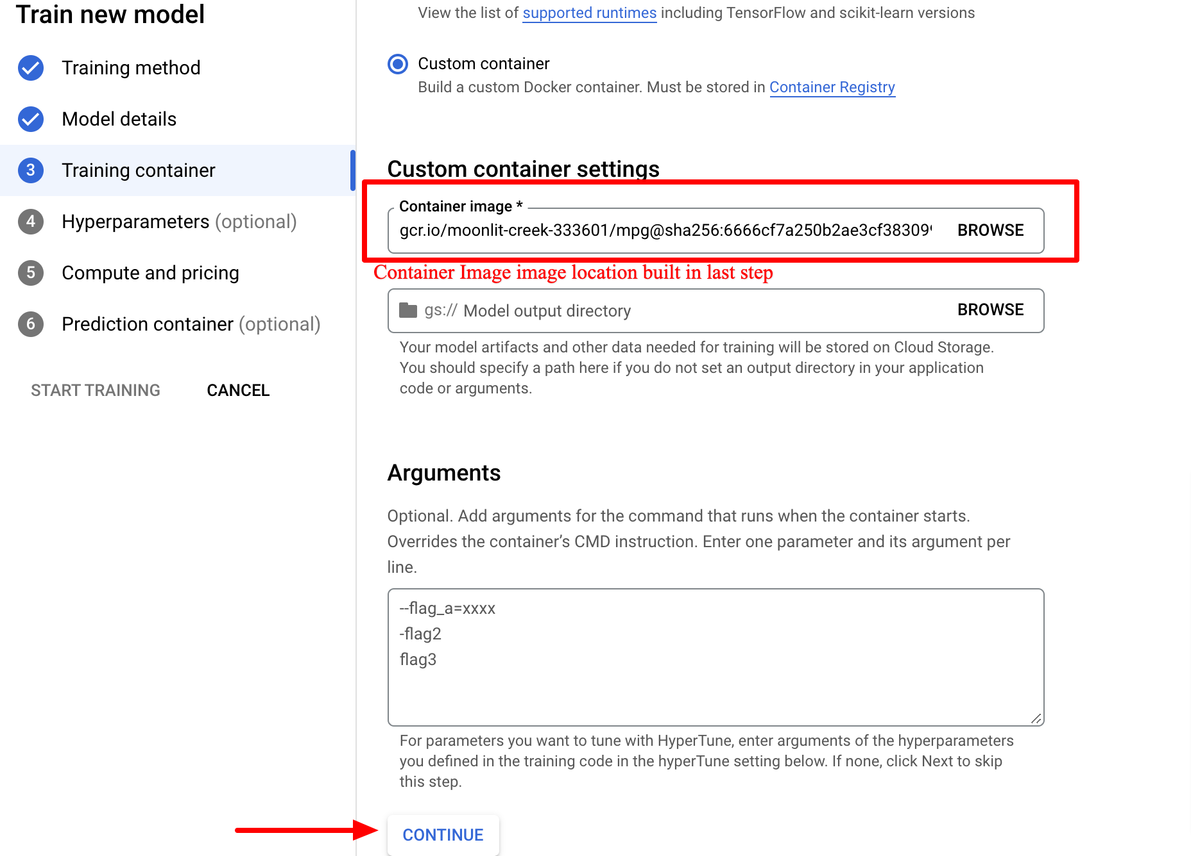

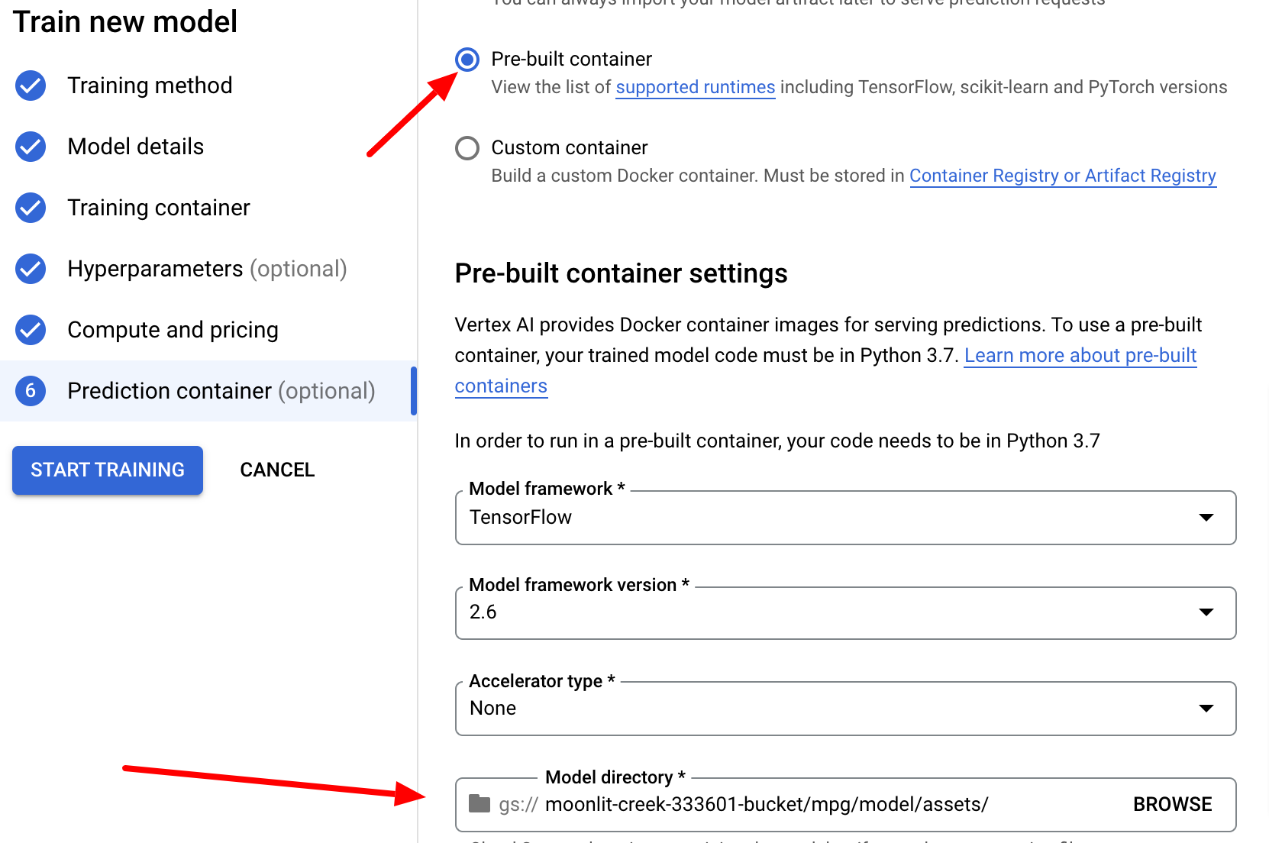

1. Deploying a model to endpoint:

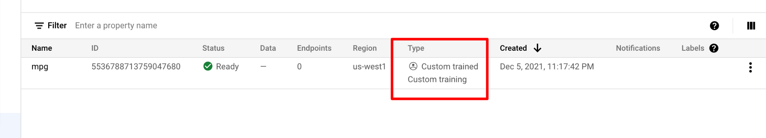

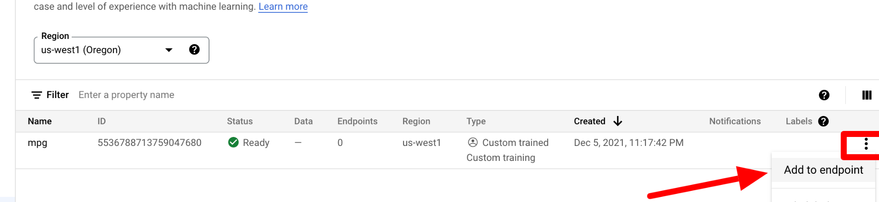

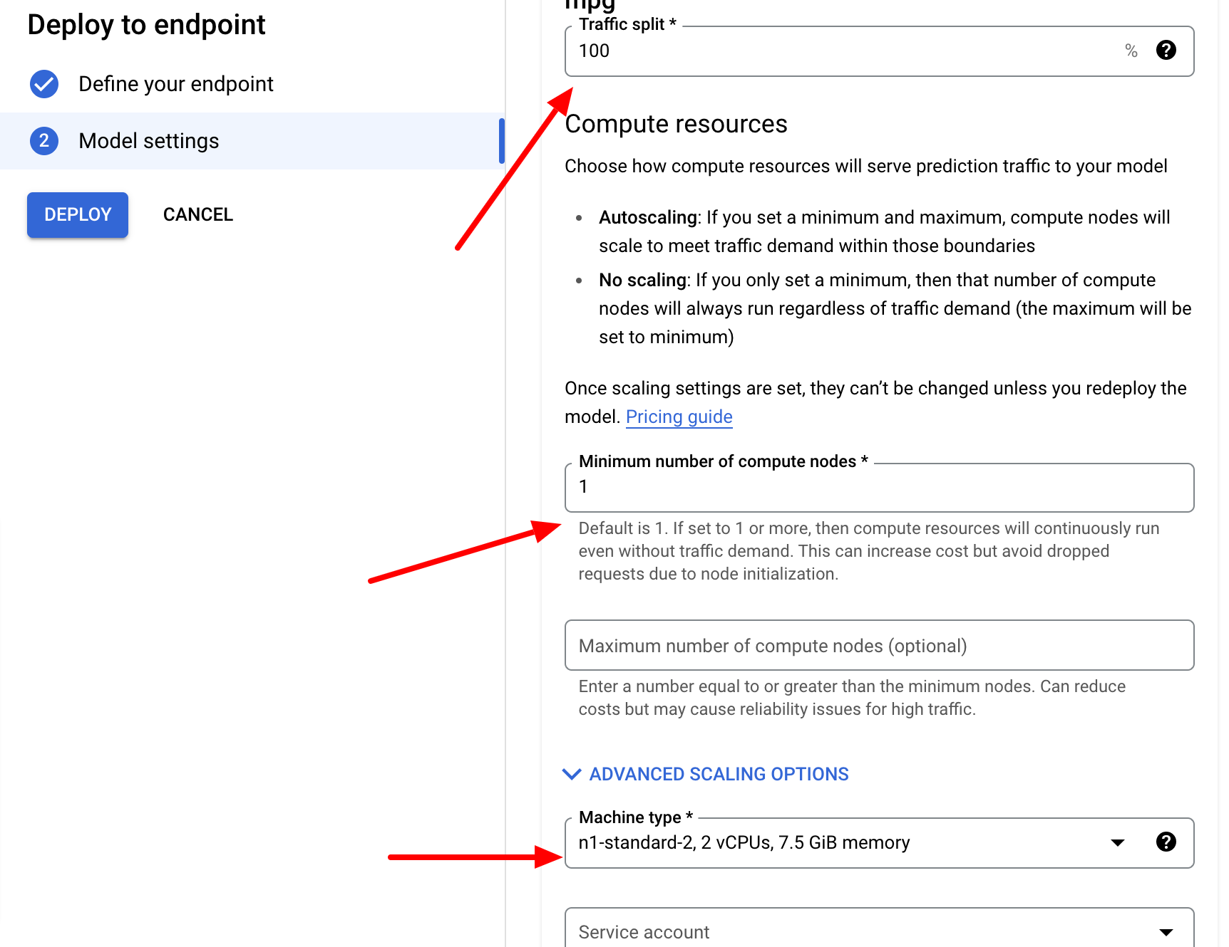



Getting the prediction in the notebook using vertex AI SDK



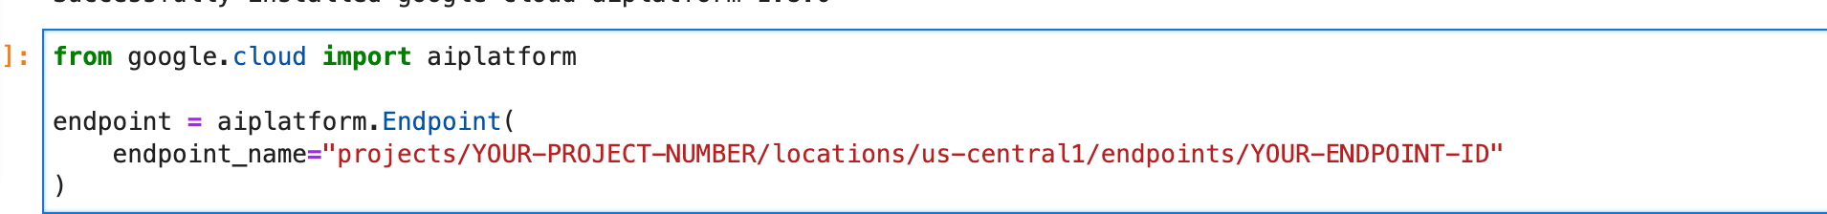

Getting the prediction in the notebook

